**SET-1**

1. Suppose that a data warehouse consists of the three dimensions time, doctor, and patient, and the two measures count and charge, where charge is the fee that a doctor charges a patient for a visit.

* Draw a star schema diagram for the above data warehouse
* Starting with the base cuboid [day, doctor, patient], what specific OLAP operations should be performed in order to list the total fee collected by each doctor in 2004?
* To obtain the same list, write an SQL query assuming the data is stored in a relational database with the schema fee (day, month, year, doctor, hospital, patient, count, charge).

Ans:

* 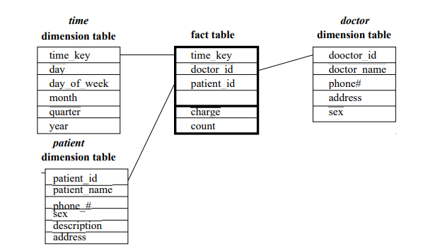Draw a star schema diagram for the above data warehouse

CREATE TABLE TTIME(TIME_KEY DATETIME PRIMARY KEY,DAY VARCHAR(10),DAY_OF_THE_WEEK VARCHAR(10),MONTH_NAME VARCHAR(10),QUARTER INT,TYEAR INT);

CREATE TABLE DOCTOR(DOCTOR_ID INT PRIMARY KEY,DOCTOR_NAME VARCHAR(20),PHONE NUMBER(10), ADDRESS VARCHAR(50), SEX VARCHAR(10));

CREATE TABLE PATIENT(PATIENT_ID INT PRIMARY KEY, PATIENT_NAME VARCHAR(20), PHONE NUMBER(10), SEX VARCHAR(10), DESCRIPTION VARCHAR(100), ADDRESS VARCHAR(50));

INSERT INTO TIME VALUES('2017-07-23 13:10:11', 22, 'MON', 'JAN','3','2014');

INSERT INTO TIME VALUES('2017-07-23 13:10:11', 22, 'MON', 'JAN','3','2014');

INSERT INTO TIME VALUES('2017-07-23 13:10:11', 22, 'MON', 'JAN','3','2014');

INSERT INTO TIME VALUES('2017-07-23 13:10:11', 22, 'MON', 'JAN','3','2014');

INSERT INTO TIME VALUES('2017-07-23 13:10:11', 22, 'MON', 'JAN','3','2014');

INSERT INTO DOCTOR VALUES (001, 'ABC', '9876654321', 'ELURU', 'MALE');

INSERT INTO DOCTOR VALUES (002, 'BCD', '9876654123', 'GUNTUR', 'FEMALE');

INSERT INTO DOCTOR VALUES (003, 'CDE', '9876612345', 'GUNTUR', 'MALE');

INSERT INTO DOCTOR VALUES (004, 'EFG', '9876654213', 'VIJAYAWADA', 'FEMALE');

INSERT INTO DOCTOR VALUES (005, 'GHI', '9876656451', 'ELURU', 'MALE');

INSERT INTO PATIENT VALUES (001, 'BDG', 9876543210, 'MALE', 'FEVER', 'ELURU');

INSERT INTO PATIENT VALUES (002, 'GHS', 8765432109, 'MALE', 'COLD', 'GUNTUR');

INSERT INTO PATIENT VALUES (003, 'SDF', 7654321098, 'MALE', 'ACCIDENT', 'ELURU');

INSERT INTO PATIENT VALUES (004, 'GSF', 6543210987, 'MALE', 'TYPHOID', 'GUNTUR');

INSERT INTO PATIENT VALUES (005, 'VXD', 5432109876, 'MALE', 'DENGUE', 'GUNTUR');

CREATE VIEW FACTT AS SELECT DOCTOR.DOCTOR_ID, PATIENT.PATIENT_ID, TIME.TIME_KEY, FROM DOCTOR, PATIENT, TIME;

DESC FACTT;

SELECT * FROM FACTT;

* Starting with the base cuboid [day, doctor, patient], what specific OLAP operations should be performed in order to list the total fee collected by each doctor in 2004?

First, we should use roll-up operation to get the year 2004(rolling-up from day then month to year). After getting that, we need to use slice operation to select (2004). Second, we should use roll-up operation again to get all patients. Then, we need to use slice operation to select (all). Finally, we get list the total fee collected by each doctor in 2004.

So,

1. ROLL UP FROM DAY TO MONTH TO YEAR

2. SLICE FOR YEAR = “2004”

3. ROLL UP ON PATIENT FROM INDIVIDUAL PATIENT TO ALL

4. SLICE FOR PATIENT = “ALL”

4. GET THE LIST OF TOTAL FEE COLLECTED BY EACH DOCTOR IN 2004

c. Ans

SELECT DOCTOR, SUM(CHARGE) FROM FEE WHERE YEAR = 2004 GROUP BY DOCTOR

1. Implementation of Text Mining on the data warehouse using weather dataset.

**SET-2**

1. Suppose that a data warehouse consists of the four dimensions, date, spectator, location, and game, and the two measures, count and charge, where charge is the fare that a spectator pays when watching a game on a given date. Spectators may be students, adults, or seniors, with each category having its own charge rate.

* Draw a star schema diagram for the data warehouse.
* Starting with the base cuboid [date, spectator, location, game], what specific OLAP operations should one perform in order to list the total charge paid by student spectators at GM Place in 2011?

***Create database, and tables in relevance to the above data warehouse***

CREATE TABLE DDATE(DATE_ID DATE PRIMARY KEY, DAY VARCHAR(10), M0NTH VARCHAR(10), QUARTER VARCHAR(10), YEAR NUMBER(4));

CREATE TABLE GAME(GAME_ID INT PRIMARY KEY, GAME_NAME VARCHAR(20),DESCRIPTION VARCHAR(50), PRODUCER VARCHAR(20));

CREATE TABLE SPECTATOR(GAME_ID INT PRIMARY KEY, SPECTATOR_NAME VARCHAR(20), STATUS VARCHAR(10),PHONE NUMBER(10),ADDRESS VARCHAR(50));

CREATE TABLE LOCATION(LOCATION_ID INT PRIMARY KEY, LOCATION_NAME VARCHAR(20), PHONE NUMBER(10), STREET VARCHAR(20), CITY VARCHAR(20), PROVINCE VARCHAR(20), COUNTRY VARCHAR(20));

Ans:

Draw a star schema diagram for the data warehouse

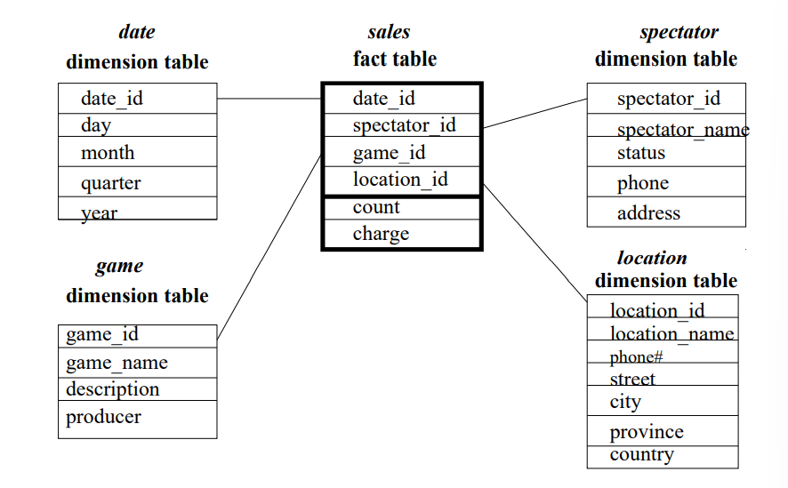

CREATE VIEW FACTT AS SELECT DDATE.DATE_ID, GAME.GAME_ID,SPECTATOR.SPECTATOR_ID, LOCATION.LOCATION_ID FROM DDATE, GAME, SPECTATOR, LOCATION;

DESC FACTT;

INSERT INTO DDATE VALUES('2019-05-21', 'MONDAY', 'JUNE', 'FIRST', 2017);

INSERT INTO DDATE VALUES('2019-05-21', 'MONDAY', 'JUNE', 'FIRST', 2017);

INSERT INTO DDATE VALUES('2019-05-21', 'MONDAY', 'JUNE', 'FIRST', 2017);

INSERT INTO GAME VALUES(001, 'PUBG', 'ACTION GAME', 'TECHO');

INSERT INTO GAME VALUES(001, 'PUBG', 'ACTION GAME', 'TECHO');

INSERT INTO GAME VALUES(001, 'PUBG', 'ACTION GAME', 'TECHO');

INSERT INTO SPECTATOR VALUES(001, 'ABC', 'ONLINE', 9876543210, 'GUNTUR');

INSERT INTO SPECTATOR VALUES(001, 'ABC', 'ONLINE', 9876543210, 'GUNTUR');

INSERT INTO SPECTATOR VALUES(001, 'ABC', 'ONLINE', 9876543210, 'GUNTUR');

INSERT INTO LOCATION VALUES(001, 'ABC', 9876543210, 'KOTHAPET', 'GUNTUR', 'SFDS', 'INDIA');

INSERT INTO LOCATION VALUES(001, 'ABC', 9876543210, 'KOTHAPET', 'GUNTUR', 'SFDS', 'INDIA');

INSERT INTO LOCATION VALUES(001, 'ABC', 9876543210, 'KOTHAPET', 'GUNTUR', 'SFDS', 'INDIA');

Starting with the base cuboid [date, spectator, location, game], what specific OLAP operations should one perform in order to list the total charge paid by student spectators at GM Place in 2011?

 ROLL-UP ON DATE FROM DATE ID TO YEAR.

2. ROLL-UP ON SPECTATOR FROM SPECTATOR ID TO STATUS.

3. ROLL-UP ON LOCATION FROM LOCATION ID TO LOCATION NAME.

4. ROLL-UP ON THE GAME FROM GAME ID TO ALL.

5. DICE WITH STATUS= “STUDENTS”, LOCATION NAME= “GM PLACE”, AND YEAR=2011

1. Implementation of Text Mining on the data warehouse using labor dataset.

**SET-3**

1. Suppose that a data warehouse for Big-University consists of the following four dimensions: student, course, semester, and instructor, and two measures count and avg grade. When at the lowest conceptual level (e.g., for a given student, course, semester, and instructor combination), the avg grade measure stores the actual course grade of the student. At higher conceptual levels, avg grade stores the average grade for the given combination.

* Draw a snowflake schema diagram for the data warehouse.
* Starting with the base cuboid [student, course, semester, instructor], what specific OLAP operations (e.g., roll-up from semester to year ) should one perform in order to list the average grade of CS courses for each Big-University student.
* If each dimension has five levels (including all), such as “student < major < status < university < all”, how many cuboids will this cube contain (including the base and apex cuboids)?

Answers:

1. Draw a snowflake schema diagram for the data warehouse.

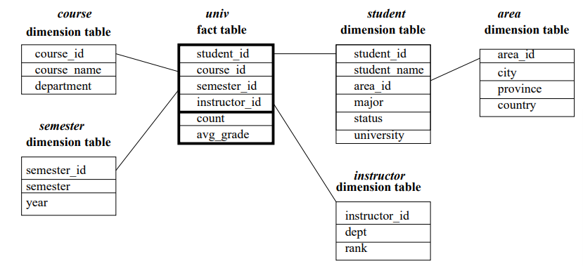

CREATE TABLE COURSE(COURSE_ID INT, COURSE_NAME VARCHAR(20), DEPARTMENT VARCHAR(20));

CREATE TABLE SEMESTER(SEMESTER_ID INT, YEAR NUMBER(4));

CREATE TABLE STUDENT(STUDENT_ID INT PRIMARY KEY, AREA_ID INT REFERENCES AREA, MAJOR VARCHAR(20), STATUS VARCHAR(20), UNIVERSITY VARCHAR(20));

CREATE TABLE AREA(AREA_ID INT PRIMARY KEY, CITY VARCHAR(20), PROVINCE VARCHAR(20), COUNTRY VARCHAR(20));

CREATE TABLE INSTRUCTOR (INSTRUCTOR_ID INT, DEPT VARCHAR(20), RANK NUMBER(3));

CREATE VIEW UNIVERSITY AS SELECT STUDENT.STUDENT_ID, COURSE.COURSE_ID, SEMESTER.SEMESTER_ID, INSTRUCTOR.INSTRUCTOR_ID FROM STUDENT, COURSE, SEMESTER, INSTRUCTOR;

DESC UNIVERSITY;

1. Starting with the base cuboid [student, course, semester, instructor], what specific OLAP operations (e.g., roll-up from semester to year ) should one perform in order to list the average grade of CS courses for each Big-University student.

* ROLL-UP ON COURSE FROM COURSE_ID TO DEPARTMENT
* ROLL-UP ON SEMESTER FROM SEMESTER_ID TO ALL
* SLICE FOR COURSE = “CS”

1. If each dimension has five levels (including all), such as “student < major < status < university < all”, how many cuboids will this cube contain (including the base and apex cuboids)?
2. Implementation of Text Mining on the data warehouse using [diabetes](http://storm.cis.fordham.edu/~gweiss/data-mining/weka-data/diabetes.arff) dataset.

**SET-4**

1. Implement star schema using multidimensional data model using SQL.

Fact table:

SALES (Product_ID, Order_ID, Customer_ID, Employer_ID, Total, Quantity, Discount)

Dimension tables:

Employee_dimension (Emp_ID, Emp_Name, Title, Department , Region)

Product_dimension (Product_ID, Product_Name, Product_Category, Unit_Price) Customer_dimension (Customer_ID, Customer_Name, Address, City, Zip)

Time_dimension (Order_ID, Order_Date, Year, Quarter, Month)

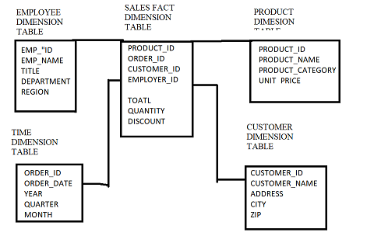

CREATE TABLE EMPLOYEE(EMP_ID INT, EMP_NAME VARCHAR(20), TITLE VARCHAR(20), DEPARTMENT VARCHAR(20), REGION VARCHAR(20));

CREATE TABLE PRODUCT(PRODUCT_ID INT, PRODUCT_NAME VARCHAR(20), PRODUCT_CATEGORY VARCHAR(20), UNIT_PRICE FLOAT);

CREATE TABLE TIME(ORDER_ID INT, ORDER_DATE VARCHAR(15), YEAR NUMBER(4), QUARTER VARCHAR(20), MONTH VARCHAR(10));

CREATE TABLE CUSTOMER(CUSTOMER_ID INT, CUSTOMER_NAME VARCHAR(20), ADDRESS VARCHAR(50), CITY VARCHAR(25), ZIP NUMBER(6));

CREATE VIEW FACTT AS SELECT PRODUCT.PRODUCT_ID, TTIME.ORDER_ID, CUSTOMER.CUSTOMER_ID, EMPLOYEE.EMP_ID FROM EMPLOYEE, PRODUCT , CUSTOMER, TTIME;

DESC FACTT;

INSERT INTO EMPLOYEE VALUES(001,'ABC','BHS', 'JHU','HUH');

INSERT INTO EMPLOYEE VALUES(002,'GFA','DSF', 'ASF', 'FSG');

INSERT INTO PRODUCT VALUES(001, 'GFSG', 'GGDD', 1254.50);

INSERT INTO PRODUCT VALUES(001, 'GSGS', 'GSRG', 1523.50);

INSERT INTO CUSTOMER VALUES(001, 'ADFA', 'FAES', 'DSFE', 532232);

INSERT INTO CUSTOMER VALUES(001, 'FRFR', 'REWR', 'SRFE', 523411);

INSERT INTO TIME VALUES(001,'23-06-2000', 1999, 'ONE', 'JUNE');

INSERT INTO TIME VALUES(001,'25-07-2000', 2003, 'TWO', 'JULY');

SELECT SUM(UNIT_PRICE) AS TOATL FROM PRODUCT GROUP BY PRODUCT_ID;

ALTER VIEW FACTT AS SELECT PRODUCT.SUM(UNIT_PRICE) AS TOATL FROM PRODUCT GROUP BY PRODUCT_ID;

1. Explore the correlation-ship analysis on weather data set

**SET-5**

1. Implement snowflake schema using multidimensional data model using SQL.

Fact table:

SALES (Product_ID, Order_ID, Customer_ID, Employer_ID, Total, Quantity, Discount)

Dimension tables:

Employee_dimension (Emp_ID, Emp_Name, Department_ID , Region, Territory)

Department_dimension (Department_ID, Name, Location)

Product_dimension (Product_ID, Product_Name, Product_Category_ID)

Product_Category_dimenstion (ProductCategoryID, Name, Description, Unit_Price)

Customer_dimension (Customer_ID, Customer_Name, Address, City_ID)

City_Dimension (City_ID, City_Name, ZIP_Code, State, Country)

Time_dimension (Order_ID, Order_Date, Year, Quarter, Month

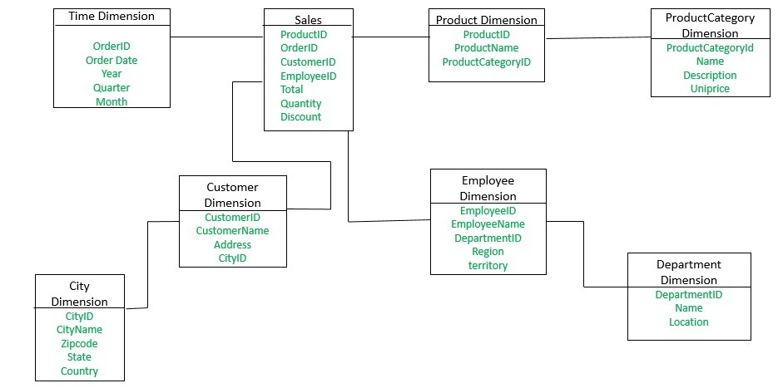

CREATE TABLE EMPLOYEE(EMPLOYEE_ID INT PRIMARY KEY, EMP_NAME VARCHAR(20), DEPARTMENT_ID INT REFERENCES DEPARTMENT, REGION VARCHAR(20),TERRITORY VARCHAR(20));

CREATE TABLE DEPARTMENT(DEPARTMENT_ID INT PRIMARY KEY, NAME VARCHAR(20), LOCATION VARCHAR(20));

CREATE TABLE PRODUCT(PRODUCT_ID INT PRIMARY KEY, PRODUCT_NAME VARCHAR(20), PRODUCT_CATEGORY_ID INT REFERENCES PRODUCT_CATEGORY);

CREATE TABLE PRODUCT_CATEGORY(PRODUCT_CATEGORY_ID INT PRIMARY KEY, NAME VARCHAR(20), DESCRIPTION VARCHAR(50), UNIT_PRICE FLOAT);

CREATE TABLE CUSTOMER(CUSTOMER_ID INT PRIMARY KEY, CUSTOMER_NAME VARCHAR(20), ADDRESS VARCHAR(30), CITY_ID INT REFERENCES CITY);

CREATE TABLE CITY(CITY_ID INT PRIMARY KEY, CITY_NAME VARCHAR(20), ZIP_CODE NUMBER(6), STATE VARCHAR(25), COUNTRY VARCHAR(20));

CREATE TABLE TIME(ORDER_ID INT, ORDER_DATE DATE, YEAR NUMBER(4), QUARTER VARCHAR(10), MONTH VARCHAR(10));

CREATE VIEW FACTT AS SELECT PRODUCT.PRODUCT_ID, TIME.ORDER_ID, CUSTOMER.CUSTOMER_ID, EMPLOYEE.EMPLOYEE_ID FROM PRODUCT, TIME, CUSTOMER, EMPLOYEE;

DESC FACTT;

SELECT * FROM FACTT;

INSERT INTO EMPLOYEE_DIMENSION VALUES(1, 'A', 'EAST', 'DELHI');

INSERT INTO EMPLOYEE_DIMENSION VALUES(2, 'B', 'NORTH', 'LADAKH');

INSERT INTO DEPARTMENT_DIMENSION VALUES(1, 'AB', 'AGRA');

INSERT INTO DEPARTMENT_DIMENSION VALUES(2, 'AC', 'TENALI');

INSERT INTO PRODUCT_DIMENSION VALUES(11,'ABC',101);

INSERT INTO PRODUCT_DIMENSION VALUES(22,'ABD',102);

INSERT INTO PRODUCT_CATEGORY_DIMENSION VALUES('AD', 'FACE CREAME', 10);

INSERT INTO PRODUCT_CATEGORY_DIMENSION VALUES('BD', 'MAKEUP KIT', 20);

INSERT INTO CUSTOMER_DIMENSION VALUES(1001, 'XY', 'BUS STAND');

INSERT INTO CUSTOMER_DIMENSION VALUES(1002, 'YZ', 'NEAR POLICE STATION');

INSERT INTO CITY_DIMENSION VALUES(10001, 'GUNTUR', 522201, 'AP', 'INDIA');

INSERT INTO CITY_DIMENSION VALUES(10002, 'VIJAYAWADA', 522001, 'AP', 'INDIA');

INSERT INTO TIME_DIMENSION VALUES(01, 25, 2022, 4, 01);

INSERT INTO TIME_DIMENSION VALUES(02, 13, 2021, 1, 12);

1. Explore the correlation-ship analysis on labor data set

**SET-6**

1. Implement Fact constellation schema using multidimensional data model using SQL.

Fact Table1: Placement (Stud_roll, Company_id, TPO_id, Number of students eligible, Number of students placed)

Fact Table2: Workshop (Stud_roll, Institute_id, TPO_id, Number of students selected, Number of students attended the workshop)

Dimension Tables:

Company (Company_id, Name, Offer_package)

Student (Student_roll, Name, CGPA)

TPO (TPO_id, Name, Age)

Training_Institute (Institute_id, Name, Full_course_fee)

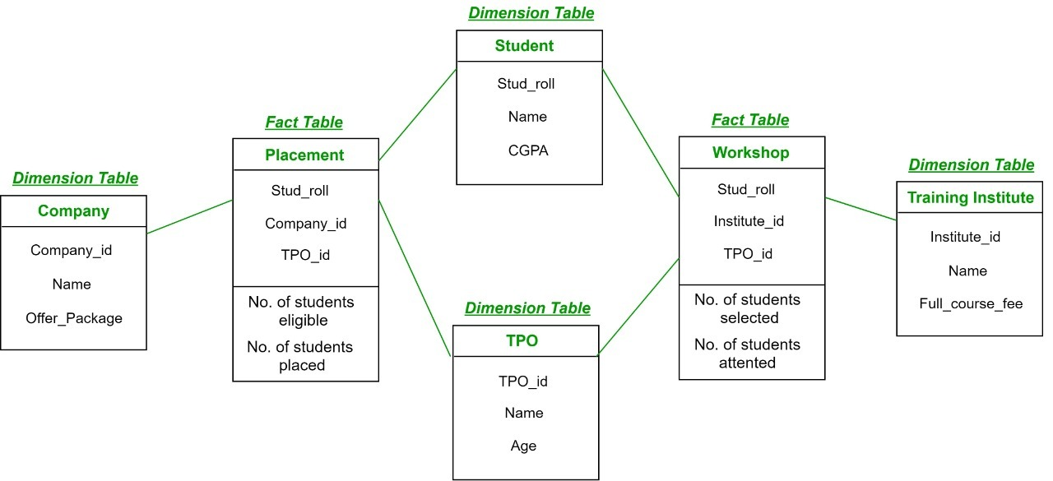

CREATE TABLE COMPANY(COMPANY_ID INTEGER PRIMARY KEY, OFFER_PACKAGE INTEGER);

CREATE TABLE STUDENT(STUDENT_ROLL INTEGER PRIMARY KEY, STUDENT_NAME VARCHAR(20), CGPA FLOAT);

CREATE TABLE TPO(TPO_ID INTEGER PRIMARY KEY, TPO_NAME VARCHAR(20), TPO_AGE INTEGER);

CREATE TABLE TRAINING_INSTITUTE(INSTITUTE_ID INTEGER PRIMARY KEY, NAME VARCHAR(20), FULL_COURSE_FEE INTEGER);

INSERT INTO COMPANY VALUES(1, 500000);

INSERT INTO COMPANY VALUES(2, 250000);

INSERT INTO STUDENT VALUES(1, 'A', 6.2);

INSERT INTO STUDENT VALUES(2, 'B', 7.6);

INSERT INTO TPO VALUES('a', 'AB', 50);

INSERT INTO TPO VALUES('b', 'BC', 60);

INSERT INTO TRAINING_INSTITUTE VALUES('101', 200000);

INSERT INTO TRAINING_INSTITUTE VALUES('102', 150000);

CREATE VIEW PLACEMENT STUDENT.STUDENT_ROLL, COMPANY.COMPANY_ID, TPO.TPO_ID FROM STUDENT, COMPANY, TPO;

CREATE VIEW WORKSHOP STUDENT.STD_ROLL, TRAINING_INSTITUTE.INSTITUTE_ID, TPO.TPO_ID FROM STUDENT, TRAINING_INSTITUTE, TPO;

1. Explore the correlation-ship analysis on [diabetes](http://storm.cis.fordham.edu/~gweiss/data-mining/weka-data/diabetes.arff) data set

**SET-7**

1. Implement star schema for the following data warehouse.

**orders_fact** The orders fact table tracks orders of spare parts. The grain of the fact table is one row per order. An order is placed by a single customer, for a single part, from a single supplier. **There are four dimensions**: **customer, part, supplier, and date.** The fact table has four measurement columns: order_quantity, order_extendedprice, order_discount, order_tax.

**customer_dim** The customer dimension includes the following attributes: name, address, nation, region, phone, account balance, market segment, and comment.

**part_dim** The part dimension includes the following attributes: name, manufacturer, brand, type, size, container, retail price, and comment.

**supplier_dim** The supplier dimension includes the following attributes: name, address, nation, region, phone, account balance, and comment.

**date_dim** The date dimension includes the following attributes: date value (a SQL date column), month name, month number, year, day of week, and day number in month.

CREATE TABLE CUSTOMER(CUSTOMER_NAME VARCHAR(20), ADDRESS VARCHAR(50), NATION VARCHAR(20), REGION VARCHAR(20), PHONE NUMBER(10), ACCOUNT_BALANCE FLOAT, MARKET_SEGMENT VARCHAR(20), CUSTOMER_COMMENT VARCHAR(10));

CREATE TABLE PART(PART_NAME VARCHAR(20), MANFACTURE VARCHAR(20), BRAND VARCHAR(20), PART_TYPE VARCHAR(20), PART_SIZE VARCHAR(10), PART_CONTAINER VARCHAR(20), RETAIL_PRICE FLOAT, PART_COMMENT VARCHAR(20));

CREATE TABLE SUPPLIER(SUPPLIER_NAME VARCHAR(20), ADDRESS VARCHAR(50), NATION VARCHAR(20), REGION VARCHAR(20), PHONE NUMBER(10), ACCOUNT_BALANCE FLOAT, SUPPLIER_COMMENT VARCHAR(10));

CREATE TABLE DDATE(DATE_VALUE DATE, MONTH_NAME VARCHAR(20), MONTH_NUMBER INTEGER, DATE_YEAR NUMBER(4), DAY_OF_WEEK VARCHAR(20), DAY_NUMBER_IN_MONTH NUMBER(2));

CREATE VIEW FACTT AS SELECT CUSTOMER.CUSTOMER_NAME, PART.PART_NAME, SUPPLIER.SUPPLIER_NAME, DDATE.DATE_VALUE FROM CUSTOMER, PART, SUPPLIER, DDATE;

DESC FACTT;

INSERT INTO CUSTOMER VALUES('A', 'GUNTUR', 'INDIA', 'EAST', 9876543210, 1000, '1', 'GOOD');

INSERT INTO CUSTOMER VALUES('B', 'VIJAYAWADA', 'INDIA', 'WEST', 8796543210, 1500, '2', 'NICE');

INSERT INTO PART_DIM VALUES('A', 'BIKE', 'HONDA', 'MIRROR', 10, 'ABC', 10, 'GOOD');

INSERT INTO PART_DIM VALUES('B', 'CAR', 'SUZUKI', 'DOOR', 50, 'BCA', 1000, 'BETTER');

INSERT INTO SUPPLIER VALUES('AB', 'TENALI', 'INDIA', 'EAST', 7894561230, 2000, 'OK');

INSERT INTO SUPPLIER VALUES('BC', 'PONNUR', 'INDIA', 'SOUTH', 8794561230, 2500, 'GOOD');

INSERT INTO DATE_DIM VALUES(2021-06-01, 'JUNE', 06, 2021, 'SUNDAY', 01);

INSERT INTO DATE_DIM VALUES(2021-05-03, MAY, 07, 2021, 'SATURDAY', 03);

1. Explore the correlation-ship analysis on supermarket dataset